FOUR ASTONS IN BRITISH GT 2013

The 2013 Avon Tyres British GT Championship is promising to be one of the most competitive in recent times and this year it will feature four Aston Martins.

Beechdean AMR, PGF- Kinfaun Racing and Barwell Motorsport will all be running the latest Vantage GT3, while Complete Racing will be competing with the Vantage GT4.

The ten race series starts on April 1 at Oulton Park and takes in Rockingham, Silverstone, Snetterton, Brands Hatch and Donington Park, as well as an overseas race at Zandvoort in Holland.

Last year, the Beechdean duo of Andrew Howard and Jonny Adam took a victory at the Nurburgring, the debut win for the new Vantage GT3. Two further podiums followed including a second place at Brands Hatch just 0.022 sec off a second victory.

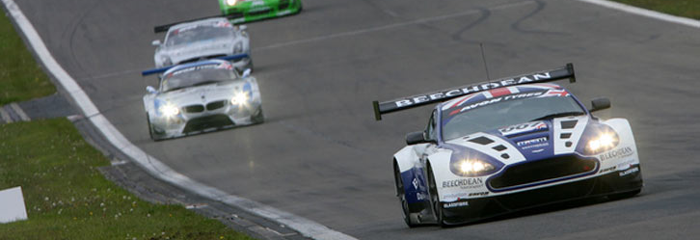
Andrew Howard, Beechdean Motorsport team principal and driver said: "Last season was very much an exploratory year for the team, myself and Jonny. We had good pace throughout the year and we’re very much looking forward to going racing in 2013 against some of the best in Europe. The series itself has taken a leap forward and is fast looking like it will be the best GT championship in Europe at this rate. It should be a great year.”
Mark Poole and Richard Abra, will drive the Barwell-prepared Vantage GT3. The two competed together in the 2011 Aston Martin GT4 Challenge of Great Britain with Generation AMR.

"For us, British GT has always been the aim of where we want to be, it's been the goal for a while now,” said Abra. “Everything we've raced in so far, we've won in, but we're under no illusions about how big a step up this will be for us. There will be a lot to learn, everything from the tyres to the competition.”

Aston Martin Racing team principal, John Gaw, pairs up again with Phil Dryburgh in the third Vantage GT3 running under the PGF-Kinfaun AMR team banner, while Steve Chaplin and Tom Wilson will share driving duties in the Complete Racing GT4 entry.

British GT Calendar 2013:
- Oulton Park April 1 2 races
- Rockingham May 5 1 race
- Silverstone May 25 1 race
- Snetterton June 15 2 races
- Brands Hatch August 10 1 race
- Zandvoort September 6 2 races
- Donington Park October 5 1 race

Follow the progress of Aston Martin Racing’s customer teams at: www.astonmartin.com/racing/

###
About Aston Martin Racing
Aston Martin Racing is the motorsport arm of Aston Martin. In 2013, it will contest the FIA World Endurance Championship with its Vantage GTE. It also has customer teams competing in major championships around the world in its Vantage GT4, GT3 and GTE cars, which all share a bonded aluminium chassis and fundamental engine design with Aston Martin's road-going V8 Vantage.
Follow the team's progress at www.facebook.com/astonmartinracing on Twitter using @amr_official and on the website www.astonmartin.com/racing.
For more information about Aston Martin Racing customer programmes contact:

James Walters
Aston Martin Racing

T: +44 (0) 1295 273 355
E: jwalters@astonmartinracing.com

